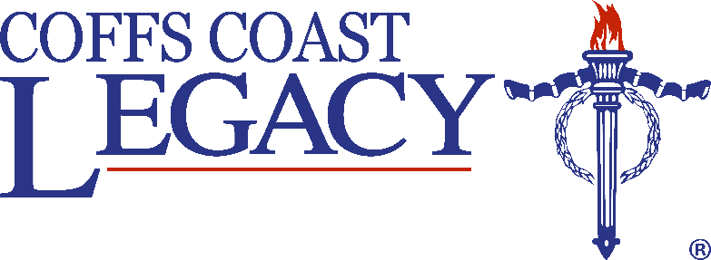

**Legacy Writing and Visual Arts**

**Competition 2017**

Coffs Coast Legacy, for the second time, is offering prizes for Year 10 and 11 to enter their Writing and Visual Arts Competition in 2017.

***What is involved?***

All students will read two texts, ‘TAG’ and ‘Well Done Those Men’ by Barry Heard.

The competition attempts to give students a short yet intriguing insight into war   
and its effect on service men and women. Students are invited to reflect on their   
learning and reflect on their own values.

***Writing Competition***

Students will put their reflections into a piece of writing.

***Visual Arts Competition***

Using the language of visual arts, students will show their reflections and convey   
the purpose of Legacy through this medium.

The competition opens from the beginning of Term 2 – 2017, and entries must be submitted by Friday 22 September 2017.

Coffs Coast Legacy will be running a workshop and panel discussion with Barry Heard and Legacy Representatives to allow competitors the opportunity to fully understand the concepts that need to be addressed in the competition. This will be during the last week of Term 1- 2017.

***Prizes***

**Year 10 Writing Year 10 &11 Visual Arts**

1st Prize $2000 1st Prize $2000

2nd Prize $1000 2nd Prize $1000

Highly Commended 5 x $100 Highly Commended 5 x $100

**For more information phone the Legacy Office on 1300 534 229**